**Abstract**

Keeping track of the assets of the company is an important task that can save companies money and time. Asset management is the process of maximizing the assets of the company to provide the best returns to stakeholders. More often than not, it involves asset recovery as well. Businesses have a wide range of assets that include fixed and liquid assets. It is important for a business to be able to manage its assets, and use them to get the maximum possible returns. Below are the top ten reasons why asset management is important. Allows the company to keep track of all assets. Asset management allows the organization to keep track of all their assets. It can tell where the assets are located, how they are used, and when changes were made to them. The data from the asset management solution can ensure that asset recovery will lead to better returns. Manage assets from different locations in an accurate and effective manner. The company can easily create an inventory report that might be required by some insurers or lease financiers. Asset recovery is automatically reflected in an asset management system. Once assets are scrapped or sold, the said assets will be removed from the records and books of the business. Related assets, such as consumables and spare parts, are written off or sold to free storage space. It brings more efficient operation. Asset management allows an organization to understand the capabilities of its assets, and how they can be operated in the most effective manner.

**Chapter 1: Theoretical Framework**

# Introduction

The management of physical assets is like any other evolving management discipline. It suffers from terminology overload. The newcomer to the subject may struggle to understand the basics. This is partly because of the unfamiliar context, but also because there are still relatively few people around to ask! This book will give newcomers a starting point from which to develop their knowledge. For those just past the starting point, it might give some structure to their understanding. For the well-seasoned asset managers out there,

Managing assets effectively for utilities is not optional these days. Across the globe, every society is faced with a significant asset management challenge:

**•** Emerging economies are trying to identify the lowest cost / highest return investments to achieve maximum immediate benefit

• Rapidly developing countries are faced with understanding the life cycle costs of their infrastructure

Good asset management can help in a number of ways to manage large expenditure and for this an asset register is vital. An asset register is essentially a list of an organization’s assets and their condition and helps an organization to ascertain what it owns or leases, the stock of that item, ﬁnd out where that asset resides and who is responsible for it. The asset register can feed into an asset management system which contains information about the asset’s maintenance schedule. The organization can plan for replacements more concisely, and it is a record for insurance claims and auditors.

**1.2 Asset Management:**

**•** Is a mind-set which sees physical assets not as inanimate and unchanging lumps of metal / plastic / concrete, but as objects and systems which respond to their environment, change and normally deteriorate with use, and progressively grow old then fail / stop working / die!

• Is a recognition that assets have a life cycle?

• Is as important for those working in finance as it is for engineers

• Is an approach that looks to get the best out of the assets for the benefit of the organization and/or its stake holders?

•Is about understanding and managing the risk associated with owning assets

If the building was planned and constructed using BIM technology, a list of assets and their details will be readily available in digital format and integrated with a CAFM system. This allows facilities managers to take informed decisions through the whole lifecycle of the facility around areas such as space use, floor planning, equipment and asset maintenance, energy consumption, and cost efficiencies.  The asset register can be compiled from a new list or information already held but it’s important to verify details by walking the building to complete an asset survey. Information can be entered directly into the register using a tablet or other device and assets cam also be tagged at this point, for example using barcodes or RFID (Radio Frequency Identification) tags. For an example of an asset register and information about the four stages of an asset’s life, please click here to request a copy of Service Works’ white paper, A Guide to Effective Asset Management for Buildings & Equipment’.

* 1. **GitHub**

GitHub [22] is a web-based Git or version control repository and Internet hosting service. It offers all of the distributed version control and Source Code Management (SCM) functionality of Git as well as adding its own features. It provides access control and several collaboration features such as bug tracking, feature requests, task management, and wikis for every project.

GitHub offers both plans for private and free repositories on the same account which are commonly used to host open-source software projects As of April 2016, GitHub reports having more than 14 million users and more than 85.5 million repositories making it the largest host of source code in the world.

Projects on GitHub can be accessed and manipulated using the standard Git command-line interface and all of the standard Git commands work with it. GitHub also allows registered and non-registered users to browse public repositories on the site. Multiple desktop clients and Git plugins have also been created by GitHub and other third parties that integrate with the platform.

The site provides social networking-like functions such as feeds, followers, and a social network graph to display how developers work on their versions of a repository is newest. A user must create an account in order to contribute content to the site, but public repositories can be browsed and downloaded by anyone. With a registered user account, users are able to discuss, manage, create repositories, submit contributions to others' repositories, and review changes to code.

GitHub is mostly used for Source code backing and concurrent execution of projects.

In addition to source code, GitHub supports the following formats and features:

* Issue tracking (including feature requests) with labels, milestones, assignees and a search engine
* Wikis
* Pull requests with code review and comments
* Commits history
* Graphs: pulse, contributors, commits, code frequency, punch card, network, members
* Integrations Directory
* Unified and split diffs
* Email notifications
* Documentation, including automatically rendered README files in a variety of Markdownlike file formats (see README files on GitHub)
* Option to subscribe someone to notifications by @ mentioning them.
* Emoji
* GitHub Pages: small websites can be hosted from public repositories on GitHub. The URL format is [http://username.github.io.](http://username.github.io/)

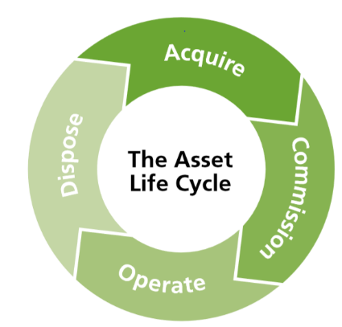**1.2 Asset Life Cycle**

Fig 1: Asset Management Life cycle.

Rapidly developing countries are faced with understanding the life cycle costs of their infrastructure

Understanding that assets have a life cycle is a key concept within Asset Management and is therefore worthy of scrutiny. There are dozens of different ways of representing the life cycle, but the diagram above captures a simple representation of it. The arrows don’t represent the length of time spent in each phase.

**1. Acquire**

This covers everything the goes into planning, designing and procuring an asset. Some life cycle diagrams capture Planning as a separate function. Proper application of these activities ensures that the asset is fit for purpose.

**2. Commission**

This covers the activities of installing / creating or building the asset and ensuring that it is fully functional. It is a recognized fact that there is a higher incidence of failure after first installation / building of an asset (Infant Mortality, see glossary). This is reflected in the need for the commissioning stage in the life cycle to oversee the initial operation of the assets.

**2. Operate**

This is normally the bulk of the life cycle for an asset during which it provides the function for which it was designed. During this period the asset should be subject to appropriate monitoring, maintenance, refurbishment and potential upgrade to meet any change in condition or operational requirement. For many assets, this phase is decades long. It may even be centuries. It is the phase that many engineers are most familiar with

**4. Dispose**

This is often the most overlooked phase. Assets can last beyond a human lifetime and it can be difficult to consider asset disposal when it is so far into the future. Asset Management teaches us that we ignore any stage of the asset

life cycle at our peril. This is a key period within an asset’s life. With some assets, e.g. in the nuclear industry, this can be an extended and highly critical period. Key activities during this period include the effective removal of the asset from operation; the disposal or recycling of the asset or its components; and the feed in to the planning for the replacement asset (if a replacement is required) to determine the operational requirements based on the effectiveness of operation and the failure modes encountered.

**1.4 MVC Framework**

The **Model-View-Controller (MVC)** is an architectural pattern that separates an application into three main logical components: the **model**, the view, and the controller. Each of these components are built to handle specific development aspects of an application. MVC is one of the most frequently used industry-standard web development framework to create scalable and extensible projects.

**Model**

The Model component corresponds to all the data-related logic that the user works with. This can represent either the data that is being transferred between the View and Controller components or any other business logic-related data. For example, a Customer object will retrieve the customer information from the database, manipulate it and update it data back to the database or use it to render data.

**View**

The View component is used for all the UI logic of the application. For example, the Customer view will include all the UI components such as text boxes, dropdowns, etc. that the final user interacts with.

**Controller**

Controllers act as an interface between Model and View components to process all the business logic and incoming requests, manipulate data using the Model component and interact with the Views to render the final output. For example, the Customer controller will handle all the interactions and inputs from the Customer View and update the database using the Customer Model. The same controller will be used to view the Customer data.

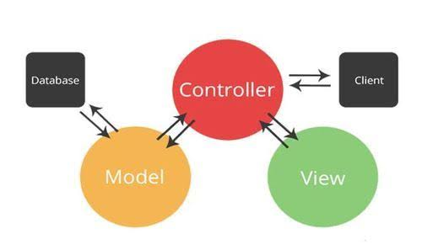

Fig 2: MVC Framework Model Diagram.

**1.5 ASP.NET MVC**

ASP.NET supports three major development models: Web Pages, Web Forms and MVC (Model View Controller). ASP.NET MVC framework is a lightweight, highly testable presentation framework that is integrated with the existing ASP.NET features, such as master pages, authentication, etc. Within .NET, this framework is defined in the System.Web.Mvc assembly. The latest version of the MVC Framework is 5.0. We use Visual Studio to create ASP.NET MVC applications which can be added as a template in Visual Studio.

ASP.NET MVC Features

ASP.NET MVC provides the following features −

Ideal for developing complex but lightweight applications.

Provides an extensible and pluggable framework, which can be easily replaced and customized. For example, if you do not wish to use the in-built Razor or ASPX View Engine, then you can use any other third-party view engines or even customize the existing ones.

Utilizes the component-based design of the application by logically dividing it into Model, View, and Controller components. This enables the developers to manage the complexity of large-scale projects and work on individual components.

MVC structure enhances the test-driven development and testability of the application, since all the components can be designed interface-based and tested using mock objects. Hence, ASP.NET MVC Framework is ideal for projects with large team of web developers.

Supports all the existing vast ASP.NET functionalities, such as Authorization and Authentication, Master Pages, Data Binding, User Controls, Memberships, ASP.NET Routing, etc.

Does not use the concept of View State (which is present in ASP.NET). This helps in building applications, which are lightweight and gives full control to the developers.

Thus, you can consider MVC Framework as a major framework built on top of ASP.NET providing a large set of added functionality focusing on component-based development and testing.

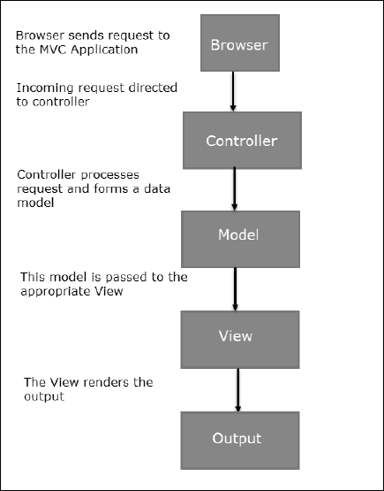

## Fig 2: MVC Flow Diagram

.

Flow Steps

Step 1 − The client browser sends request to the MVC Application.

Step 2 − Global.ascx receives this request and performs routing based on the URL of the incoming request using the RouteTable, RouteData, UrlRoutingModule and MvcRouteHandler objects.

Step 2 − This routing operation calls the appropriate controller and executes it using the IControllerFactory object and MvcHandler object's Execute method.

Step 4 − The Controller processes the data using Model and invokes the appropriate method using ControllerActionInvoker object

Step 5 − The processed Model is then passed to the View, which in turn renders the final output.

MVC and ASP.NET Web Forms are inter-related yet different models of development, depending on the requirement of the application and other factors. At a high level, you can consider that MVC is an advanced and sophisticated web application framework designed with separation of concerns and testability in mind. Both the frameworks have their advantages and disadvantages depending on specific requirements.

Visual Applications are developed using Java language. Java is object oriented programming language. Java is very popular programming language owned by Oracle. Developed long after C and C++, Java incorporates many of the powerful features of those powerful languages while addressing some of their drawback. Still, programming languages are only as powerful as their libraries. These libraries exist to help developers build applications. Some of the Java’s important features are-It is easy to learn and understand. It is designed to be platform-independent and secure, using virtual machines.

Visual relies heavily on these java fundamentals. The Visual SDK includes many standard Java libraries like data structures libraries, math libraries, graphics libraries, networking libraries and everything else a developer wants as well as special Visual libraries that will help develop awesome Visual Applications. However, now the official language for developing Visual apps is Kotlin.

**1.6 Objective**

The objectives of this dissertation is to-

* To develop a web application to manage asset.
* To provide a system that can be used by different departments of Sikkim.
* To design user friendly and efficient User Interface.
  1. **Scope**

Dictionary definition of risk is: “(Exposure to) the possibility of loss, injury, or other adverse or unwelcome circumstance; a chance or situation involving such a possibility.”The management of risk within asset management is critical. Why? Because asset managers are responsible for OPTIMISING outcomes for the good of their organization, and therefore need to make judgments about which actions best achieve the right blend of outcomes based on organizational objectives. To make these judgment’s, they need to predict how their actions will impact on the future performance of the assets. They need to quantify both the probability of their actions (or inactions) causing a change in performance and then they need to determine the impact or consequences of that change in performance.

Risk = Probability X Consequence (of failure).

# Chapter 2 Methodology

# 2.1 Development Environment

The minimum hardware and software requirements for developing SU-Connect are as follows-

**2.1.1 Hardware Requirement**

* Min 4GB RAM, 8GB recommended (if less than this configuration the system, Visual studio will be installed but not run smoothly and the system may crash)
* Min Intel i5 Core Processor.
* Min 250 GB Disk space.

**2.1.2 Software Requirement**

* Visual Studio 2.2.2.
* Windows/Linux/ Mac Operating System.
* Git Installation.
* Java JDK 7 or later version and Java Runtime Environment (JRE)
* Visual SDK
* Visual Development Tools (VDT) Eclipse Plug-in (optional))

# 2.2 Proposed Methodology

This section describes the various proposed methods and procedures being followed throughout this phase of the project. The project is divided into seven phases:

* 1. Phase I: Planning.
  2. Phase II : Literature Survey
  3. Phase III: Data Collection
  4. Phase IV : Design
  5. Phase V : Coding
  6. Phase VI : Testing
  7. Phase VII : Deployment

These phases are discussed in the succeeding sub sections.

# 2.2.1 Planning

# We came with many ideas and slowly we put this ideas in different modules and finally we come with 6 different modules for our idea. We divided the work among 6 Developer.

During this phase, a software model was designed that would be followed during the development of the app in which the developer can go to design from testing or coding and coding to testing phase as and when required and repeat it till the module works efficiently.



Requirement Gathering



Deployment



Testing



Coding



Design

Figure 2.2: Software Model

After that, team members divided different modules and started developing. And if the decided modules completes in time, then others modules will be focused on.

# 2.2.2 Data Collection

For this project development, an environment is built by integrated as follows:

* Visual Studio as IDE (Integrated Development Environment)
* GitHub as Repository for saving our programming codes to cloud.
* SQL as web server.

Visual Studio is used for developing the app along with various SDKs.

To perform concurrent execution of modules GitHub is required so that team member don’t have to wait till the module that is to completed before starting another. When one module is completed it is pushed (store) in GitHub repository and the other member who needs it can pull it from GitHub repository and need not to wait for other team member to complete it. It also helps in integration of modules when completed.

SQL is used as a server and the database of this application is stored in PHP my admin.

# 2.2.4 Design

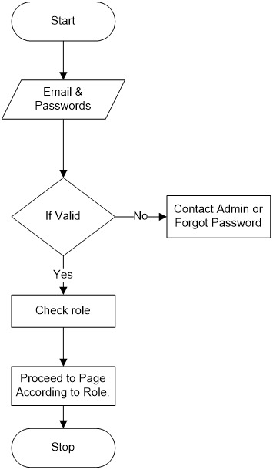

Figure 2.2: Flow chart for Signing up..

We have prepared for tables for the project for now namely,

**User**: It is the one who will use the software and gets involved into it.

E.g. -: one user can be admin/Updater.

**Department**: It contains the organization who will use

The Software for their purpose.

**Asset Table:** It contains all the assets that a department uses and their status like: is it been using still or broken or obsolete, it also show the user who is assigned the particular asset representing by a unique tag/id/number to the asset

**Asset Catogery**: It could be anything like furniture/electronics/files/papers/stationary items etc.

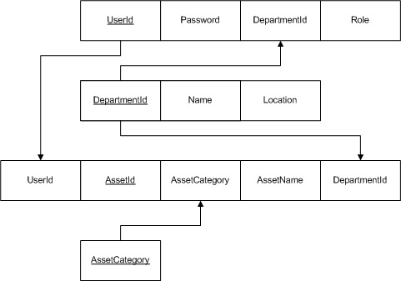

Fig 2.3: Flow chart for Signing up.

Signing up is the Initial process where user is categorized whether he/she is admin or simply a user. If the user is not having the unique key or id and the password with him/her he will not be able to access the database page. In order to overcome this problem he/she has too contact the admin or if the problem is not perusing then the user is able to view the database.

Admin have the root permission (means he can read/write/update) the database while in other side the simple user can only read the database if he/she has an account on the domain.

# The class diagram in Figure 2.12 depicts the actual working of the Department module. Here the class GUI_Structre_Inflater helps the Main Activity class to inflate the layout of the respective size defined in the programme.

# Now the Function_Provider class will extract the name, Image phone_number attributes from the file named String and put it into its respective layouts and to make this layout(like buttons and image) working class Working_GUI will make it clickable. So the Working_GUI class is a compostion of GUI_Structre_Inflater and Function_Provider class Getter and Setter is used in this module for making the data private from the outer users and Class School and Departments are for the users to choose their intentions of data and the Main Activity will create the list of individual row and make visible to the users.

# 2.2.4 Coding

Coding in this app was done using two languages, which is JAVA and XML (Extended Markup Language). XML files were used for creating the layout and design of the app. Graphic features were included in the app using XML drawable file and the view of the app was done by modifying the Visual layout file. The design of user interface was carried out using XML files and these XML files are handled and activated using corresponding Java files.

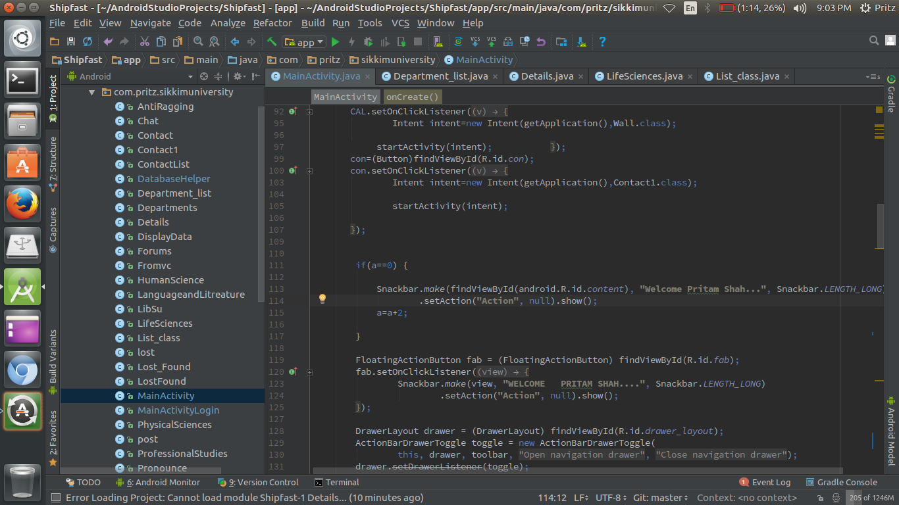

Figure 2.12: Screenshot of Coding in Visual Studio

There are currently **29 Java files** and **45 XML**. There are 58 drawable files in Drawable folder and **208 images** are used in the App.

Some of the algorithms of used in the app development are given as follows:

1. Algorithm Name: Forums

Input: Message (Strings)

Step 1: Start

Step 2: If (internet connectivity)

2.1 Read message say ‘a’

2.2 Extract name and department name

2.2 Concatenate name and department name save it to a variable ‘c’

2.4 Set value of reference to a and c and push.

2.5 Repeat step 2.1 till exit

2.6 End if

Step 2 Else

2.1 Read message say ‘a’ and place it in cache.

2.2 Repeat step 2.1

Step Stop

1. Algorithm Name: Lost/Found

Input: Image and Strings

Step 1: Start

Step 2: Read image from content provider.

Step 2: Read title and description.

Step 4: Place (image, title and description) in cache.

Step 5: if(internet connectivity)

5.1 Push it to database.

5.2 End if.

Step 6: Else

6.1 Print No Internet

Step 7: Stop

# 2.2.5 Testing

The app is tested in many version of Visual in order to check if the app developed till date:

* Responds correctly to all kinds of inputs.
* To be able to handle abnormal values
* Can be install to all the version of Visual Environments.
* Meets the requirements that guided its design and development.
* Performs its functions within an acceptable time.
* To check how it behaves when no internet is there.

Initially, the app used to crash 6 times out of 10 when tested, but it hardly crashed now.

As the app can be deployed in almost all version of Visual. , this app used to crashes in many older version of Visual like Jelly Bean (4.0), Jelly Bean (4.1) and even on KitKat (4.4). The app was tested several times and now the app does not behaves abnormal.

**Unit Testing**: After completing the code of each module in the app, it was tested individually to verify its functioning.

**Integration Testing**: After the coding was completed along with the unit testing, the entire code of the app was tested in version Jelly Bean to Marshmallow.

**System Testing**: System testing was carried out in the emulator as well as few Visual devices to test completely integrated app in order to verify that the app meets its requirements.

The results of testing was good and many bugs were fixed after testing and the app is optimized and the good thing is that the app can run on any Visual device version from **Ice cream(4.0)** to latest **Nougat (7.0)** of any **Screen size.**

The app size is currently only **6.9 MB** in spite of having many offline capabilities.

# 2.2.6 Deployment

After proper completion of the testing phase, the app was ready to be deployed on any Visual device. A primary test was conducted first on the Visual Emulator with different Visual Virtual Device (supported environments on varieties of Phones) to see if the app is working properly or not.

This was followed by a real time test on Visual Phones to see if real time errors occurs.

The app was deployed on following phones-

* Gionee P2S [Jelly Bean (4.1)]
* Java Iris[Kitkat (4.4)]
* Redmi 2s [Marshmallow (6.0)]
* Lenovo 2266 [Lollipop(5.0)]

**Chapter 4: Results**

**4.1 Result**

The screenshot of database of SU-Connect is as follows-

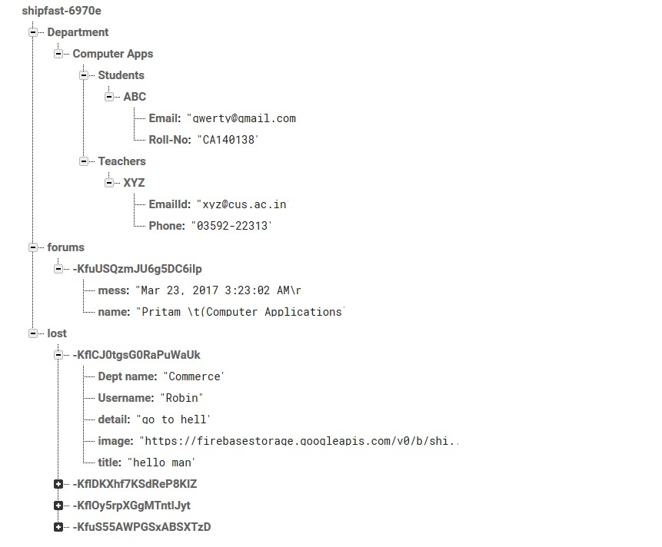

Figure 4.1: Screenshot of Database of SU-Connect

-

The Following are the snapshots taken on running the app on an Visual Devices are-

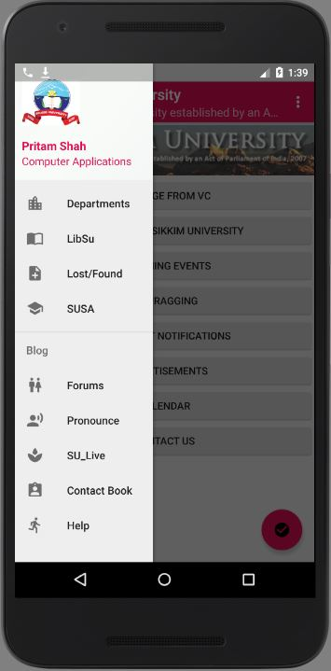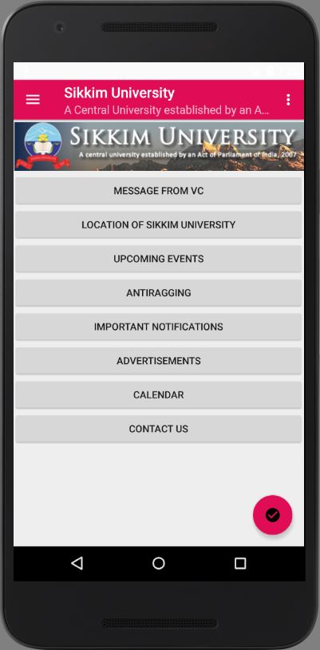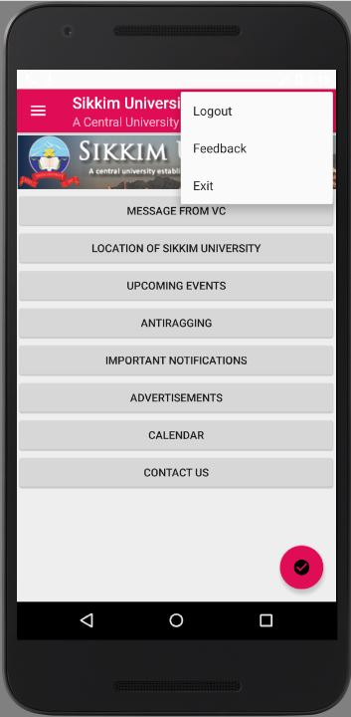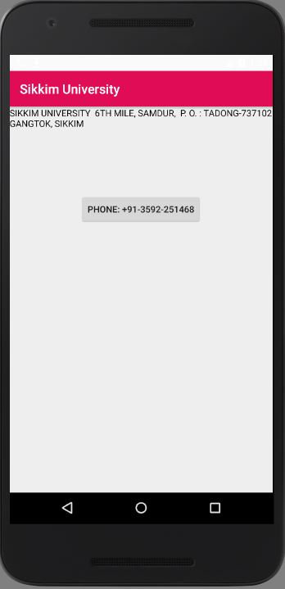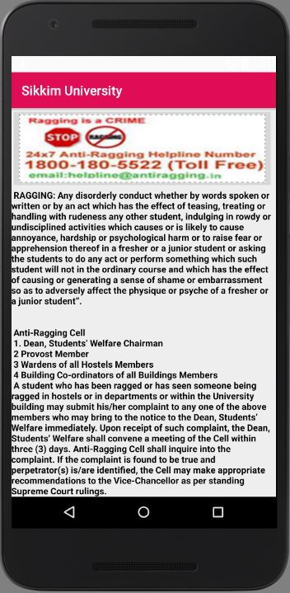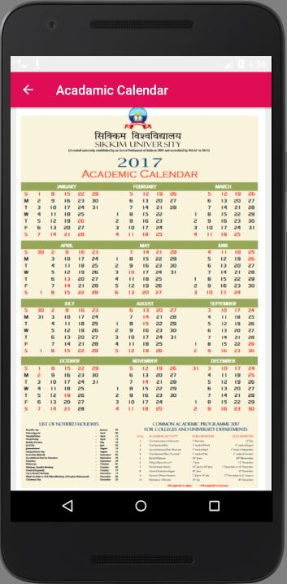

1. (b) (c)

(d) (e) (f)

Figure 4.2: Snapshots of (a)Navigation Drawer,(b)Home Screen, (c) Settings Menu,(d) Antiragging,(e)Academics Calendar,(f)Contact SU.

Figure 4.2: Snapshots of (a) Schools, (b)Schools of Professionals Studies,(c) Physical Sciences, (d)School of Life Sciences,(e) School of Human Sciences (f) School of Language and Literature

(d) (e) (f)

(a) (b) (c)

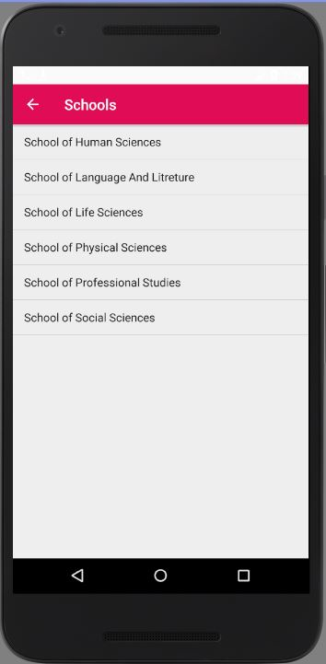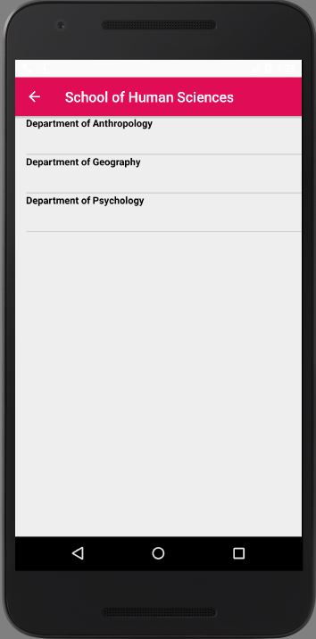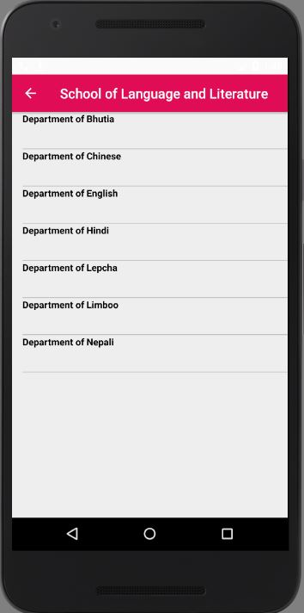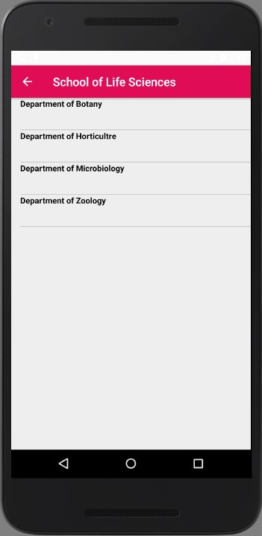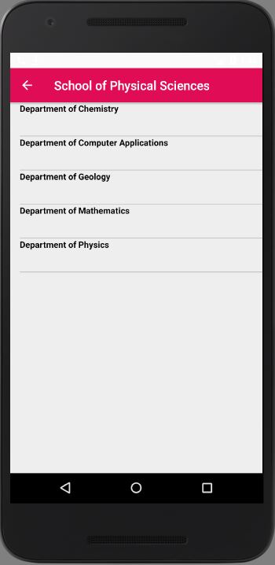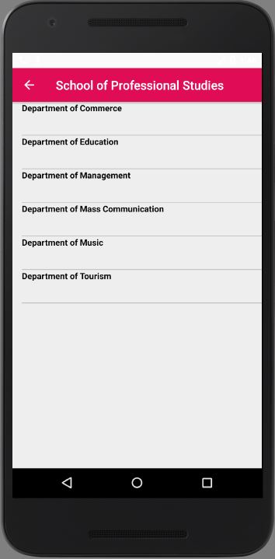

(d) (e) (f)

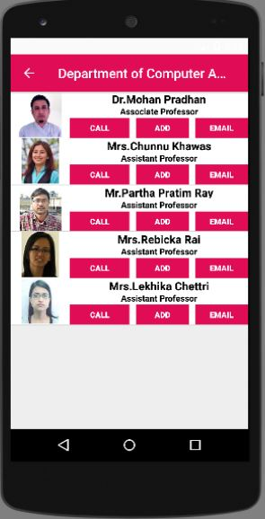

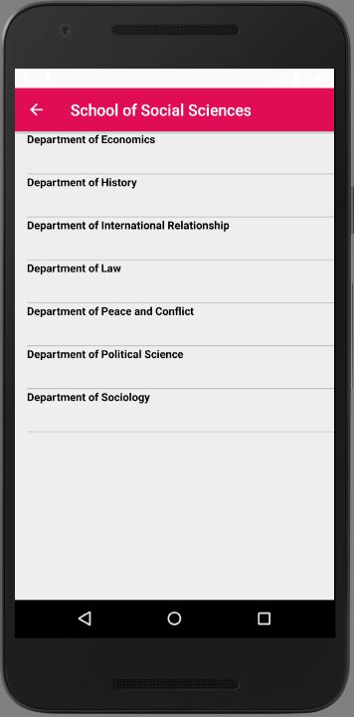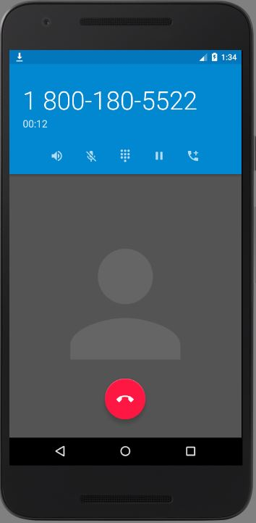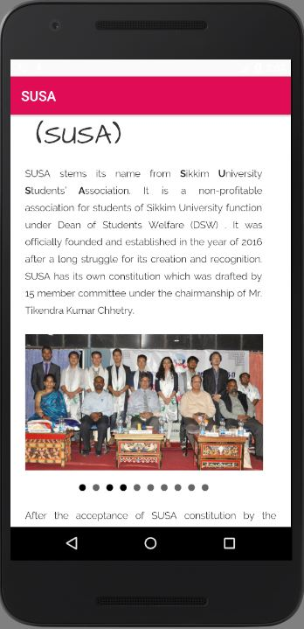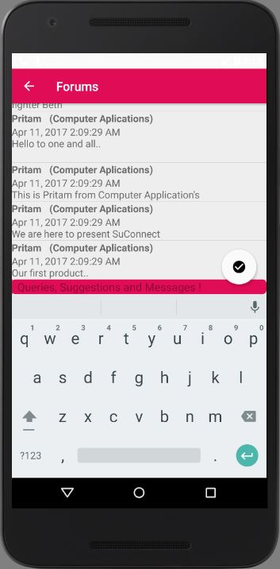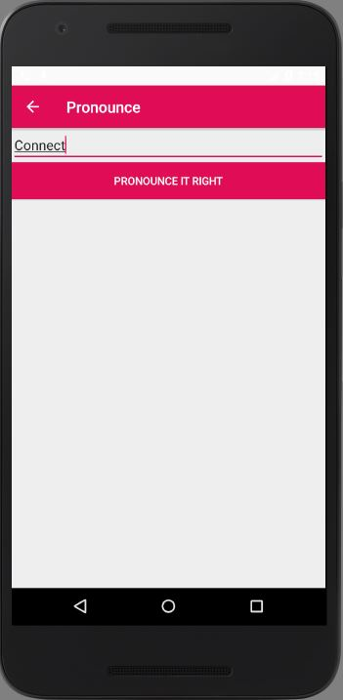

(d) (e) (f)

(a) (b) (c)

Figure 4.4: Snapshots of (a) School of Social Sciences, (b)Department of Computer Applications,(c) Call on button pressed, (d)Pronunciation Activity (e) Forums(f) Sikkim University Students’ Association

(a) (b) (c)

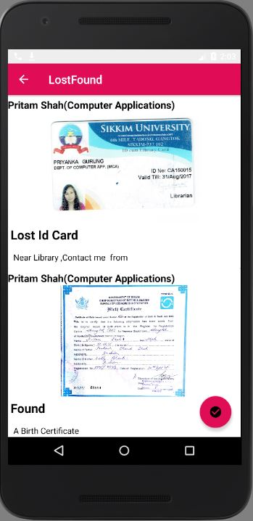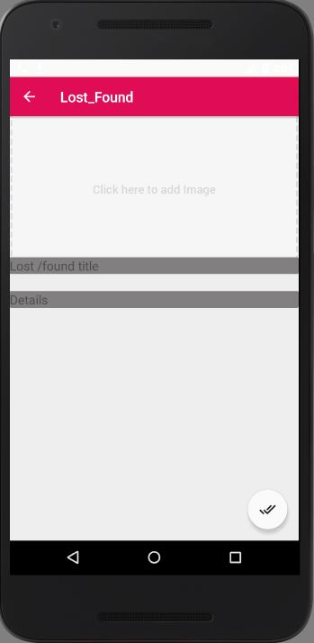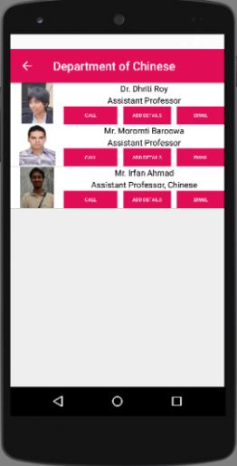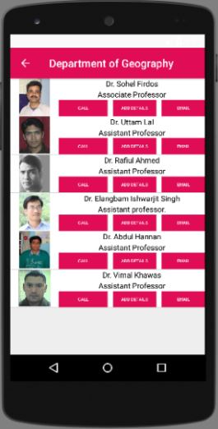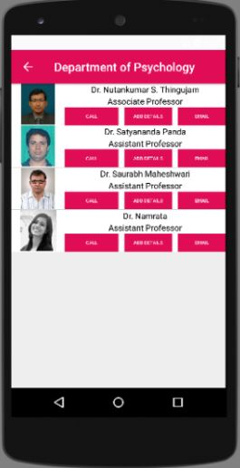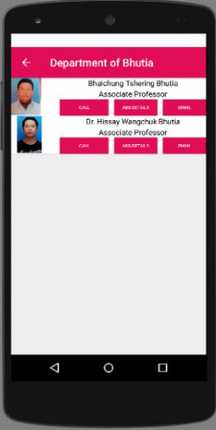

(d) (e) (f)

Figure 4.5: Snapshots of (a) Lost/Found Post Activity, (b)Lost/Found Wall,(c) Department of Bhutia, (d)Department of Geography, (e) Department of Chinese,(f) Department of Psychology

(a) (b) (c)

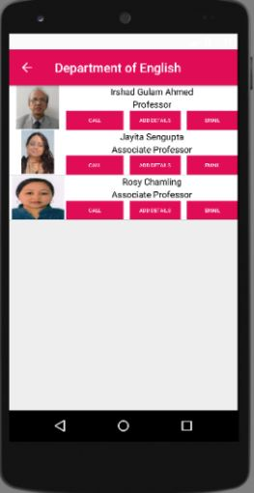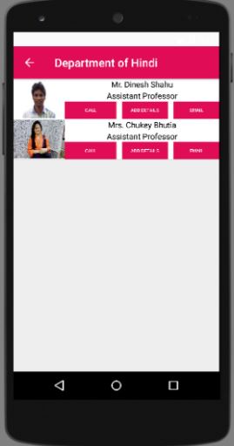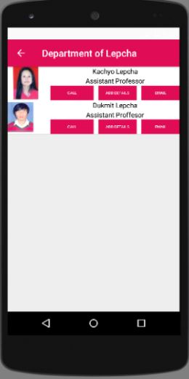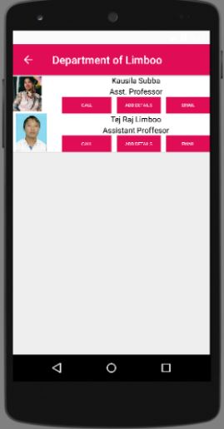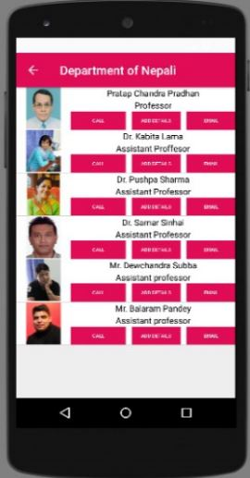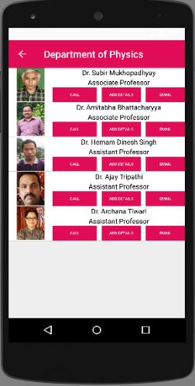

(d) (e) (f)

Figure 4.6: Snapshots of (a) Department of Lepcha, (b)Department of Limboo,(c) Department of Nepali, (d)Department of Hindi, (e) Department of English,(f) Department of Physics

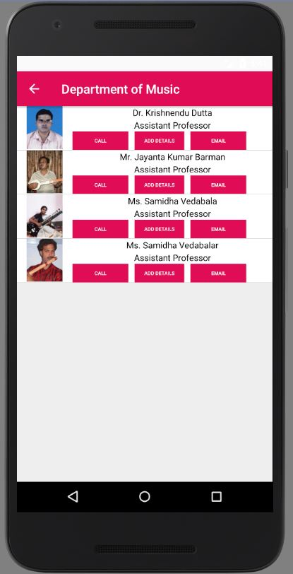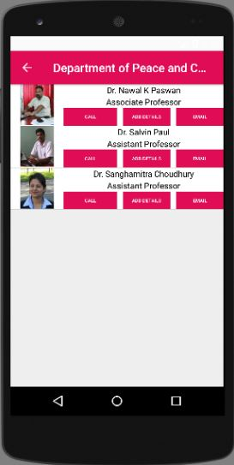

(d) (e) (f)

(a) (b) (c)

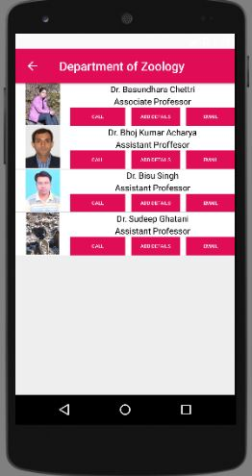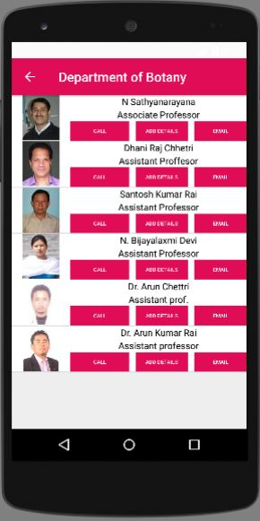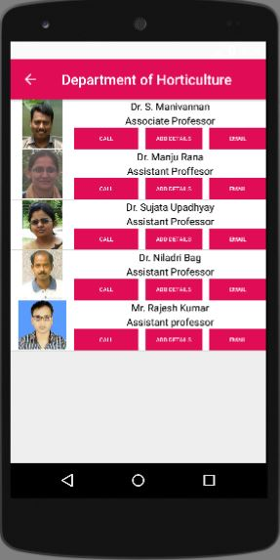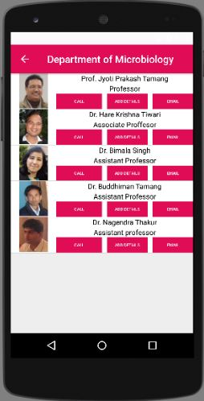

Figure 4.7: Snapshots of (a) Department of Botany, (b)Department of Horticulture,(c) Department of Microbiology, (d)Department of Music, (e) Department of Peace and Conflict,(f) Department of Zoology

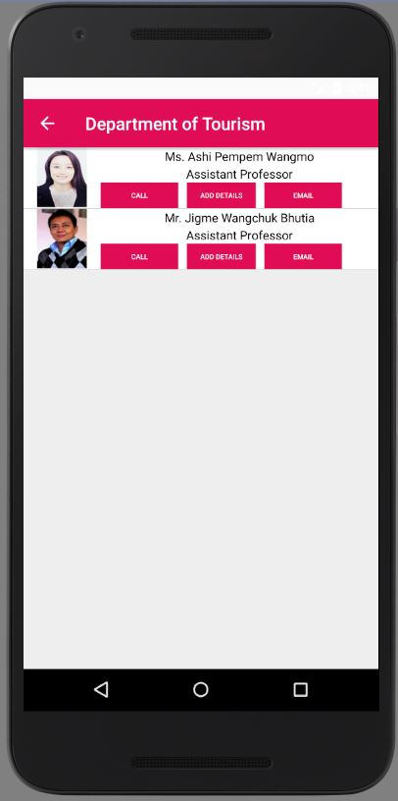

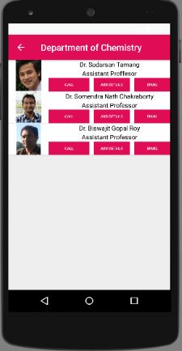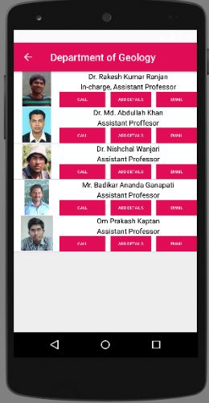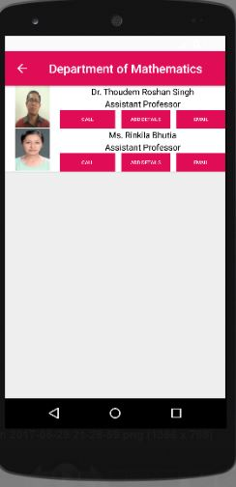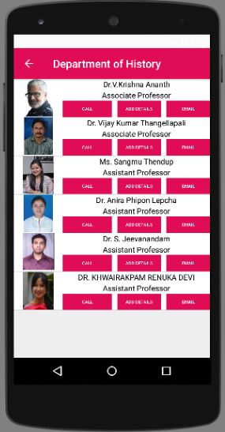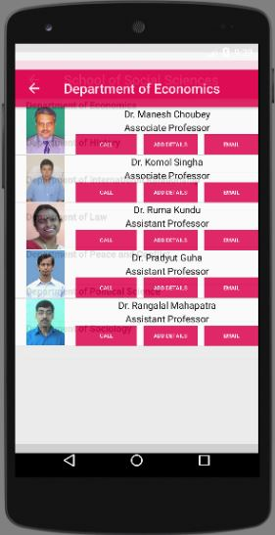

(d) (e) (f)

(a) (b) (c)

Figure 4.8: Snapshots of (a) Department of Chemistry, (b)Department of Geology,(c) Department of Economics, (d)Department of History, (e) Department of Tourism,(f) Department of Economics

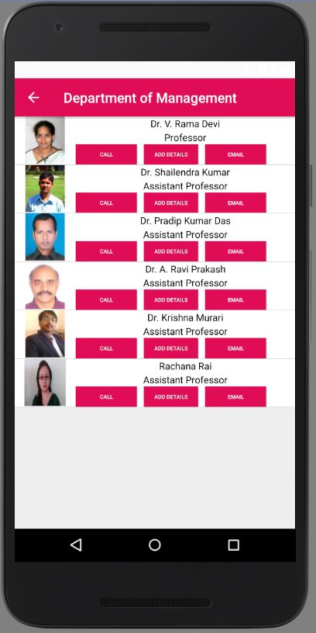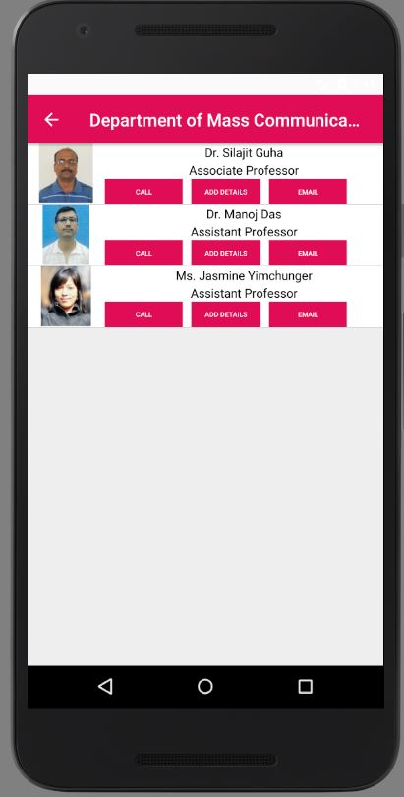

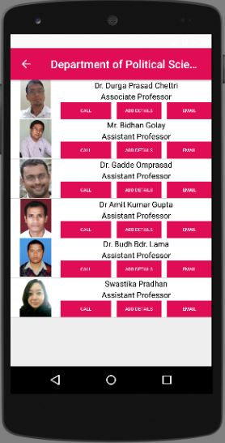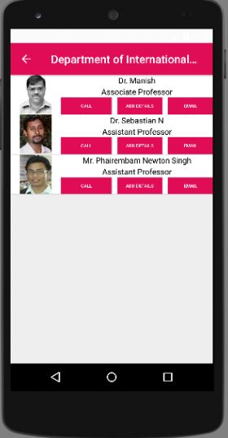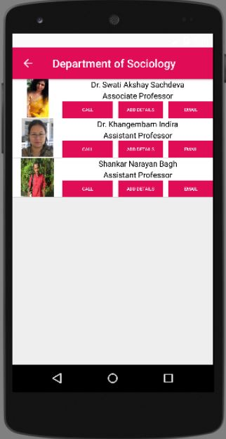

(d) (e) (f)

Figure 4.9: Snapshots of (a) Department of Mass Communication, (b)Department of Sociology,(c) Department of Management, (d)Department of International Relations, (e) Department of Law,(f) Department of Political Sciences

(a) (b) (c)

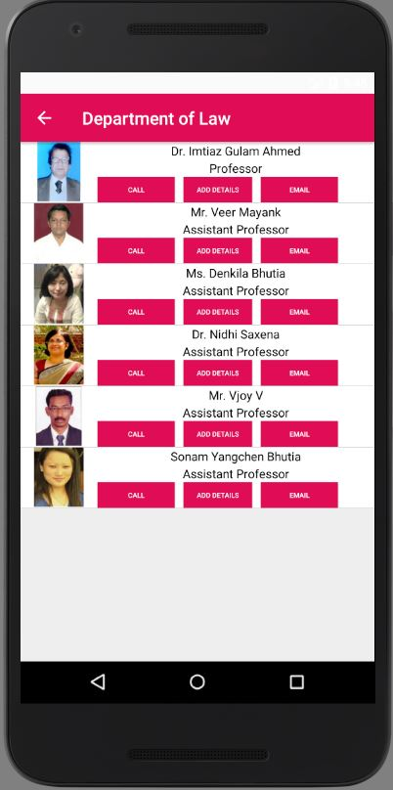

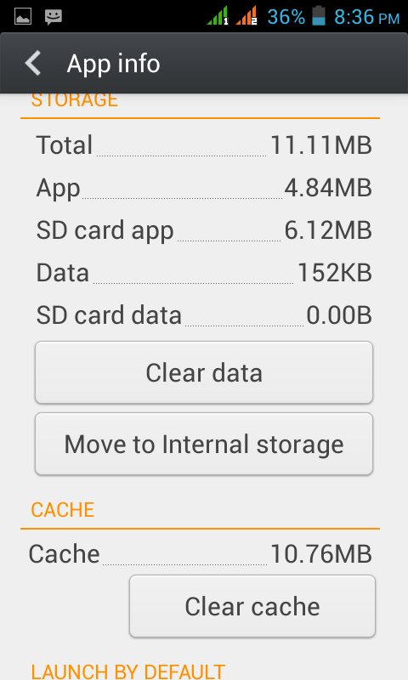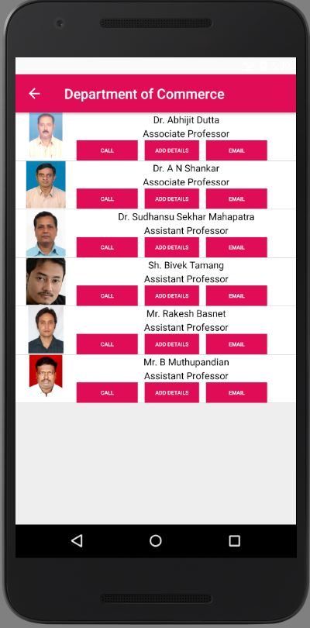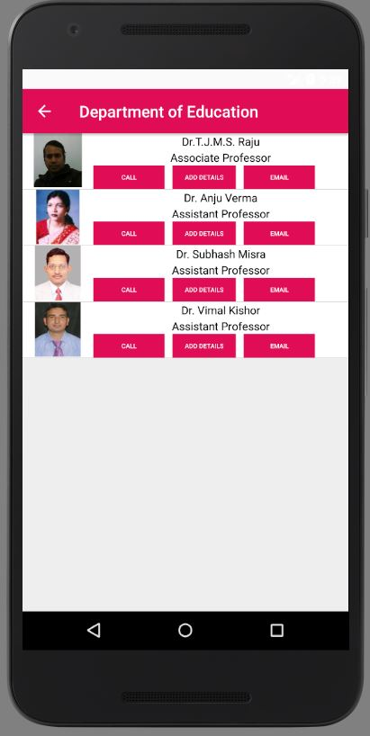

(a) (b) (c)

Figure 4.10: Snapshots of (a) Department of Education, (b) Department of Commerce, (c) Cache of app

**4.1 Limitation**

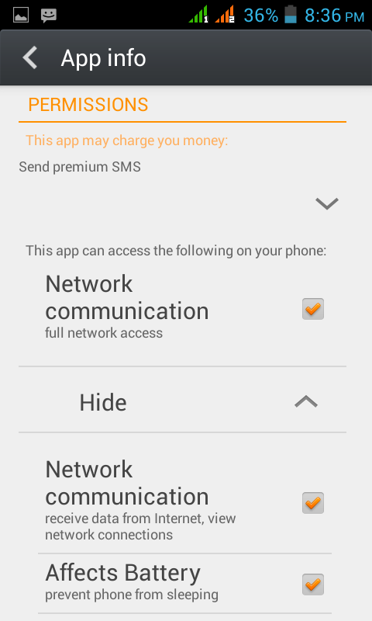This section consists of limitations of the App that is listed below:

There are many Visual user but there are other users like Windows, IOS and this app is only deployable for Visual user.

But later on SU-Connect can be developed for Windows and IOS. Currently, SU-Connect is only available for Students ,but university app should cover teachers and staffs also ,so in future SU-Connect can be made available for teachers and staffs of Sikkim University. As from Figure 4.11 it’s clear that this app works efficiently when there is internet connectivity and its affects battery.

Figure 4.11 Permission required for Su-Connect

**Chapter 5: Conclusion and Future work**

**5.1 Conclusion**

SU-Connect is in the phase of optimization, there are lot of things that needs to be optimized. The app size is small, though we are trying to reduce the size to make it more light weight.

SU-Connect fits the some of the contents of website in a small Visual app. Sikkim University has scattered campus around the town Gangtok, Sikkim. That’s why there is communication gap between the students of departments. Data transfer is not efficient as there is 22 department here and there is no timeliness of data from one department to another. This app will focus on minimizing the problem of timeliness of data and make it easy for the Students to build a communication easier.

Sikkim University has a website but there is no application available for it. Since nowadays most of the university has their own app, this application might serve the requirement of having an app.

**5.2 Future Work**

There are many more modules to be worked on like –

* GPS Bus Location- Users can get to know where the bus have reached and when will it arrive. Users can get notification if the bus is delayed or missed.
* Ad Post- Users can give advertisements about anything that is happening in their Department. Local Companies can also give advertisements to SU that can generate revenue for SU.
* Voting- It’s like audience poll, to know what the users think about a particular topic.
* Face of the week- There are many real life heroes and inspiration in SU that should be highlighted and made famous. This module serves the same with details of that person.
* NSS `Activity- As SU NSS cell is very active and it try to reach every social welfare events with enormous students and teachers as its members. This module provides them the platform to share their ideas and work efficiently.
* Blood Donation Activity- This module collects the blood group of every user that is signed in and creates a database by calculating the number of users having a particular blood group and displaying it those who are ready to donate their blood along with their contact details. Those who needs it they can contact the particular people.
* Wall- This is the coolest feature a university app can have allowing the users( Teachers, Students, Non-teaching staffs) to post anything in the university wall just like that of Facebook.
* And many more to be incorporated in this app in future.

**References**

1. Deepa V. Jose, Lakshmi Priya C, G. Priyadarshini, Monisha Singh, “Challenges and Issues in Visual App Development- An Overview”, International Journal of Computer Science and Mobile Computing, IJCSMC, Vol. 4, Issue. 5, May 2015, pg.294 – 299.
2. Liu, Jianye, and Jiankun Yu. "Research on Development of Visual Applications." Fourth International conference on Intelligent Networks and Intelligent Systems. 2011. [7/2/17]
3. Peng, Bin, JinmingYue, and Chen Tianzhou. "The Visual Application Development College Challenge." High Performance Computing and Communication & 2012 IEEE 9th International Conference on Embedded Software and Systems (HPCC-ICESS), 2012 IEEE 14th International Conference on. IEEE, 2012. . [7/2/17]
4. The Times Of India Online newspaper. “Indian Weth prefers WhatsApp, Facebook over SMS” published on June 16, 2012. . [7/2/17]
5. [http://www.tutorialpoints.com/Visual/Visual_programming.htm.](http://www.tutorialpoints.com/android/android_programming.htm) [12/2/17] a.%mobile7c=apps&hl=en.v
6. http://www.andoridstudio.tektips.in/Visual-studio-system-requirements.aspx. . [12/2/17]
7. http://www.W2schools%20Offline%20Version/www.w2schools.com/xml/default.asp. [12/2/17]
8. http://www.tubemate/apk.com[12/2/17]
9. Official Sikkim University website -http://www.cus.ac.in. [12/2/17]
10. [http://playstore.google.com/store/search?SikkimM](http://playstore.google.com/store/search?Sikkim)anipal %University7c=apps&hl=en. [12/2/17]
11. http://playstore.google.com/store/search?SMUDE %12c=apps&hl=en[12/2/17]
12. http://playstore.google.com/store/search?/SRM %27c=apps&hl=en. [12/2/17]
13. http://playstore.google.com/store/search?PTU 55c=apps&hl=en. [12/2/17]
14. [http://playstore.google.com/store/search?Amity%University7c=apps&hl=en.](http://playstore.google.com/store/search?Amity%25University7c=apps&hl=en) [12/2/17]
15. http://playstore.google.com/store/search?MIT %University7c=apps&hl=en. [12/2/17]
16. http://playstore.google.com/store/search?Harvard Connection %University72c=apps&hl=en. [16/2/17]
17. [http://playstore.google.com/store/search?Whatsappc=apps&hl=en.](http://playstore.google.com/store/search?Whatsappc=apps&hl=en) [16/2/17]
18. [http://playstore.google.com/store/search?Gmail.inc7c=apps&hl=en[](http://playstore.google.com/store/search?Gmail.inc7c=apps&hl=en)16/2/17]
19. [http://playstore.google.com/store/search?Instagram?djf7c=apps&hl=en.](http://playstore.google.com/store/search?Instagram?djf7c=apps&hl=en) [16/2/17]
20. [http://playstore.google.com/store/search?facebook%lite=apps&hl=en.](http://playstore.google.com/store/search?facebook%25lite=apps&hl=en)
21. [http://www.tubemate/apk/v4.com.](http://www.tubemate/apk/v4.com) [17/2/17]
22. <http://www.gooogle/images/architectue/diagram>[17/2/17]
23. [http://github_documents.com.[18/2/17]](http://github_documents.com.[18/2/17)
24. //http:developer_documents.Visual_studio.com[18/2/17
25. [http://SQL/documents/Visual.com.[18/2/17]](http://firebase/documents/android.com.%5b18/2/17)

**Bibliography**

1. Adam Gerber, Clifton Craig, “Learn Visual Studio”, Apress, 2015. . [7/2/17]
2. Data Communication and Computer Networks 5th Edition by Michael Duck and Richard Read. . [10/2/17]
3. “The Complete Reference Java” 7Th Edition by Herbert Schildt. . [10/2/17]
4. Data Communications and Computer Networks for Computer Scientists and Engineers 2nd Edition Michael Duck and Richard Read. . [10/2/17]
5. Reto Meier’s Professional Visual application development. [10/2/17]
6. Visual Programming Tutorials 4th Edition by Mark L. Murphy. . [10/2/17]
7. Tutorial on Client-Server Communications EE268/CS222 Digital Image Processing, spring 2015 Version for Wer Personal Computer. . [10/2/17]
8. Neil Smyth’s Visual Studio Development Essentials. . [10/2/17]

dfhdfdfhdfbc

*~~IX-2~~*

*~~IX-2~~*

*~~IX-1~~*